Updating/Editing a Training Program on the Eligible Training Provider List

- Log in to your ETPL account https://joblink.maine.gov/training

- Go to your training institution’s account.

- Use the Manage Programs feature. You should see a display of your institution’s programs.
- Select the program you want to update to and hit edit 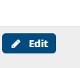 .

- This is the next screen you should see. To update the program, select Edit Program under 6 above.

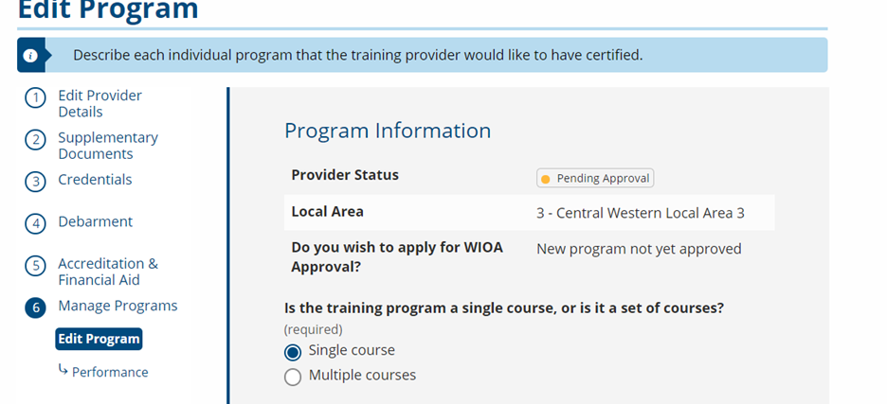

- Make your changes and select Finish or Save.

